**Topics: Descriptive Statistics and Probability**

1. Look at the data given below. Plot the data, find the outliers and find out $μ, σ, σ^{2}$

|  |  |
| --- | --- |
| **Name of company** | **Measure X** |
| Allied Signal | 24.23% |
| Bankers Trust | 25.53% |
| General Mills | 25.41% |
| ITT Industries | 24.14% |
| J.P.Morgan & Co. | 29.62% |
| Lehman Brothers | 28.25% |
| Marriott | 25.81% |
| MCI | 24.39% |
| Merrill Lynch | 40.26% |
| Microsoft | 32.95% |
| Morgan Stanley | 91.36% |
| Sun Microsystems | 25.99% |
| Travelers | 39.42% |
| US Airways | 26.71% |
| Warner-Lambert | 35.00% |

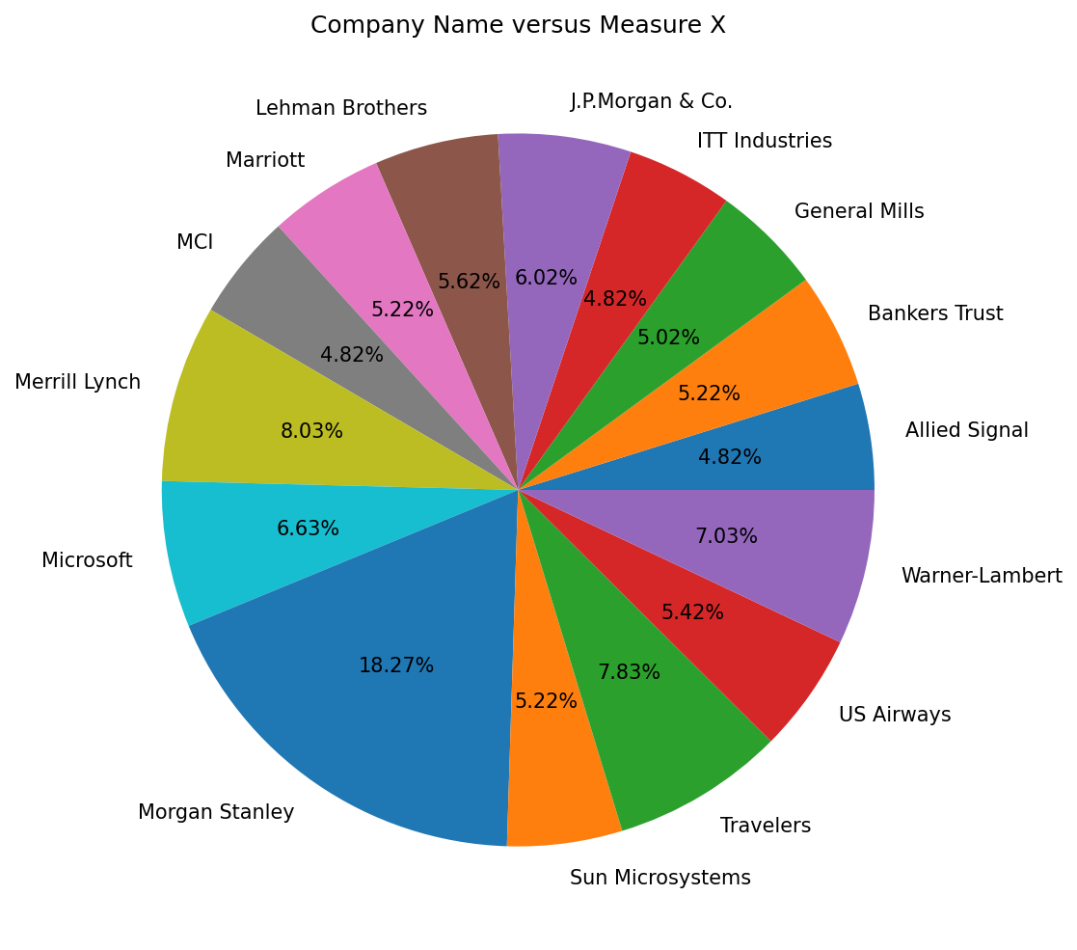

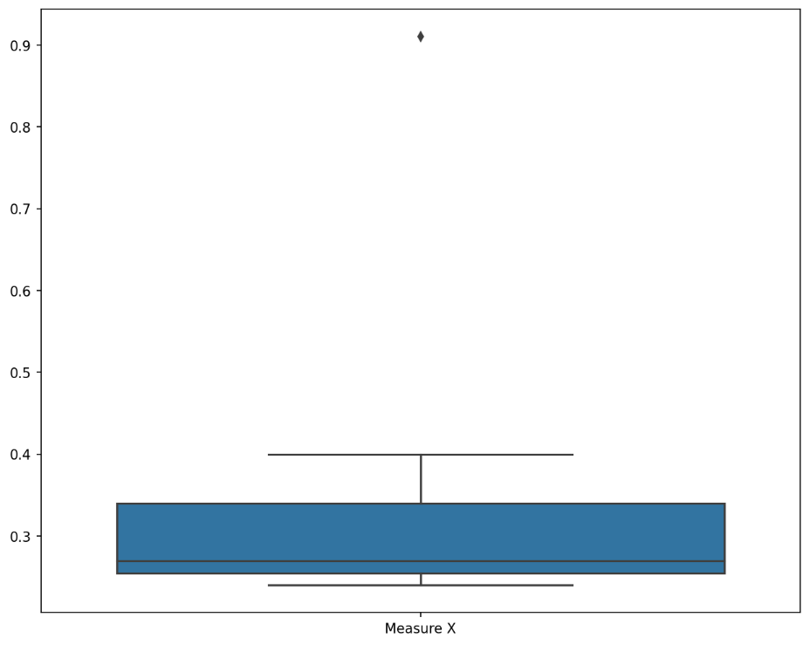

There is the outlier in the boxplot: Morgan Stanley **91.36%**

* Mean = 33.27
* Standard deviation = 16.95
* Variance = 2.650



Answer the following three questions based on the box-plot above.

1. What is inter-quartile range of this dataset? (please approximate the numbers) In one line, explain what this value implies.

**Answer:-**

First Quantile Range Q1 = 5

Median Q2 = 7

Third Quantile Range Q3 = 12

Inter-Quartile Range = IQR = Q3 – Q1 = 12 – 5 = 7

1. What can we say about the skewness of this dataset?

**Answer :-**

There is right-skewness in above dataset

1. If it was found that the data point with the value 25 is actually 2.5, how would the new box-plot be affected?

**Answer :-**

In that case there would be no outliers on the given dataset.



Answer the following three questions based on the histogram above.

1. Where would the mode of this dataset lie?

**Answer :-**

The mode of data lie between 4 and 10.

1. Comment on the skewness of the dataset.

**Answer :-**

Above histogram is right-skewed.

1. Suppose that the above histogram and the box-plot in question 2 are plotted for the same dataset. Explain how these graphs complement each other in providing information about any dataset.

**Answer :-**

Both the graphs are right-skewed and both have outliers towards upper extreme.

We can easily find mode of dataset using histogram and median can be visualized in Boxplot.

1. AT&T was running commercials in 1990 aimed at luring back customers who had switched to one of the other long-distance phone service providers. One such commercial shows a businessman trying to reach Phoenix and mistakenly getting Fiji, where a half-naked native on a beach responds incomprehensibly in Polynesian. When asked about this advertisement, AT&T admitted that the portrayed incident did not actually take place but added that this was an enactment of something that “could happen.” Suppose that one in 200 long-distance telephone calls is misdirected. What is the probability that at least one in five attempted telephone calls reaches the wrong number? (Assume independence of attempts.)

**Answer :-**

Let's define the events as follows:

E1 = event of a call reaching the wrong number

E2 = event of a call reaching the correct number

E3 = event of at least one in five calls reaching the wrong number

We know that P(E1) = 1/200

P(E2) = 1 – P(E2)

= 1 – (1/200)

= 199/200

Now, the probability for at least one in five attempted telephone calls reaches the wrong number

n = 5, p = 1/200, q = 199/200

P(E3) = at least one in five attempted telephone calls reaches the wrong number

P(E3) = ⁿCₓ pˣ qⁿ⁻ˣ

P(E3) = (nCx) (p^x) (q^n-x)

P(E3) = (5C1) (1/200)^1 (199/200)^(5-1)

**P(E3) = 0.0245037**

The probability that at least one in five attempted telephone calls reaches the wrong number

Is 2.45 %.

1. Returns on a certain business venture, to the nearest $1,000, are known to follow the following probability distribution

|  |  |
| --- | --- |
| x | P(x) |
| -2,000 | 0.1 |
| -1,000 | 0.1 |
| 0 | 0.2 |
| 1000 | 0.2 |
| 2000 | 0.3 |
| 3000 | 0.1 |

|  |  |
| --- | --- |
| E(X) = Sum X * P(X) | E(X^2) =X^2*P(X) |
| -200 | 400000 |
| -100 | 100000 |
| 0 | 0 |
| 200 | 200000 |
| 600 | 1200000 |
| 300 | 900000 |
| **Total:-** 800 | **Total:-** 2800000 |

1. What is the most likely monetary outcome of the business venture?

**Answer :-**

The most likely monetary outcome of the business venture is **2000$**.

As for **2000$** the probability is **0.3** which is maximum as compared to others.

1. Is the venture likely to be successful? Explain

**Answer :-**

Yes, the probability that the venture will make more than 0 or a profit

p(x>0)+p(x>1000)+p(x>2000)+p(x=3000)

= 0.2+0.2+0.3+0.1

= 0.8

This states that there is a good **80%** chances for this venture to be making a profit.

1. What is the long-term average earning of business ventures of this kind? Explain

**Answer :-**

The long-term average is Expected value = Sum (X * P(X)) = **800$** which means on an average the returns will be **+ 800$**.

1. What is the good measure of the risk involved in a venture of this kind? Compute this measure

**Answer :-**

The good measure of the risk involved in a venture of this kind depends on the Variability in the distribution. Higher Variance means more chances of risk

Var (X) = E(X^2) –(E(X))^2

= 2800000 – 800^2

= **2160000**